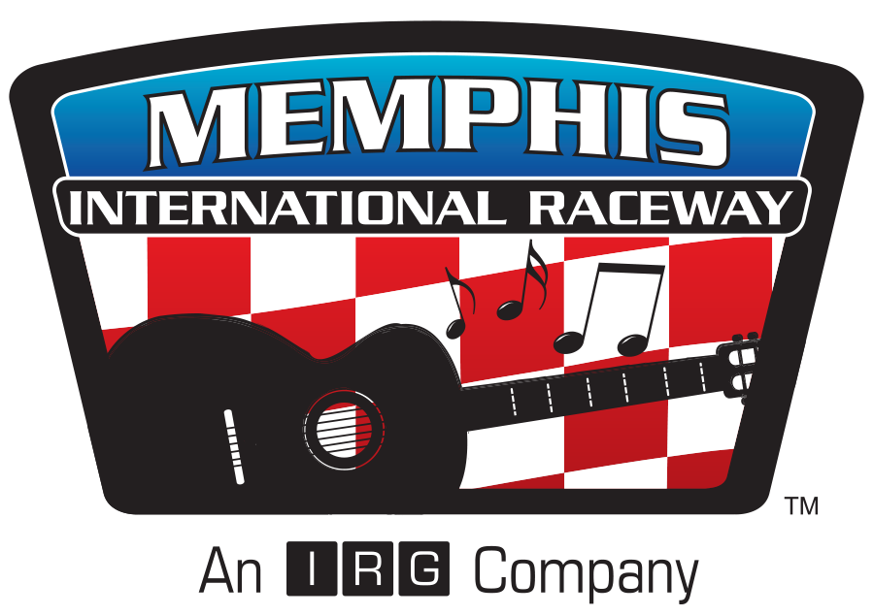

Media Credentials Request Form for
World Series of Drag Racing presented by Sunoco & Memphis Convention & Visitors Bureau

WHAT: All media personnel who cover the World Series of Drag Racing at Memphis International Raceway will need to submit a Media Credential Request online.

WHEN: Now

WHERE: online at this link: http://bit.ly/WSODMediaCredentials2016

WHO: Any and all media personnel planning to attend and cover the World Series of Drag Racing at Memphis International Raceway August 26-27
Reporters
Photographers
Videographers
Bloggers

CONTACT: Patrick Collins
901-219-9944
patrick@mmgmemphis.com

