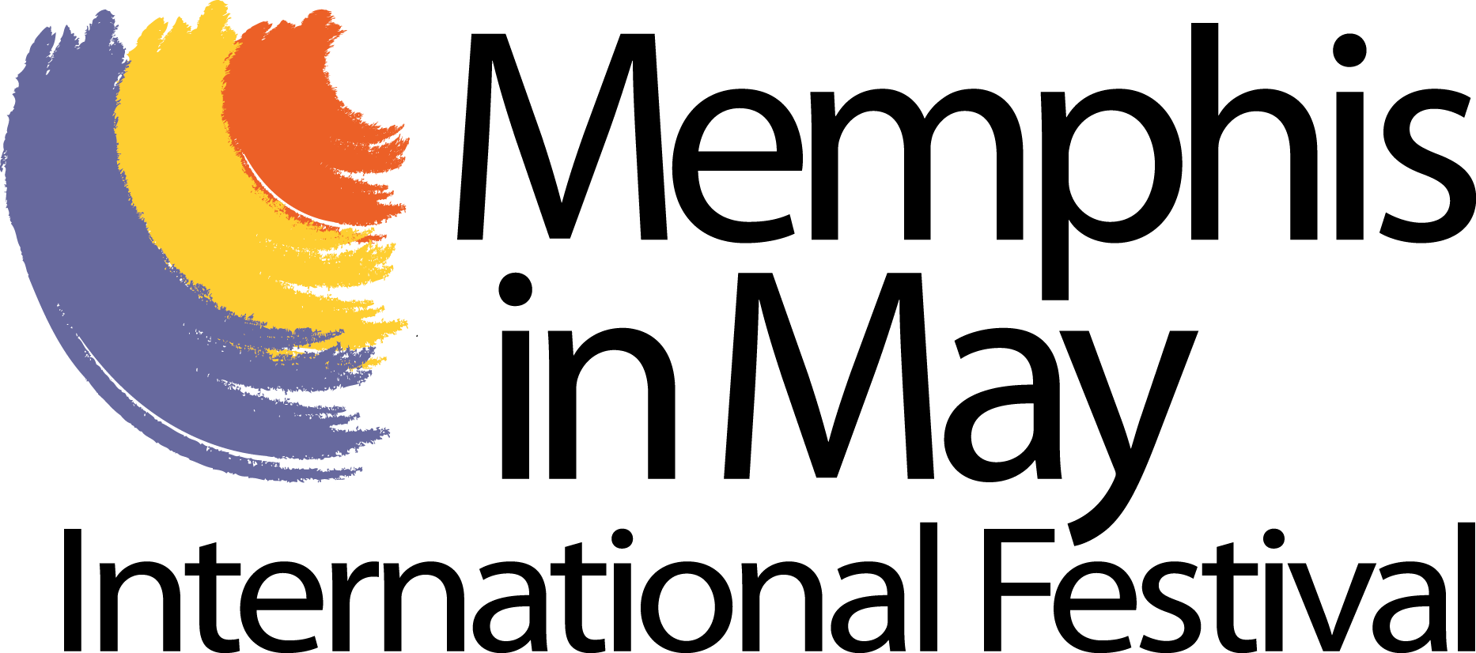
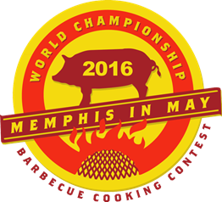

FOR IMMEDIATE RELEASE
Contact: Penelope Huston
phuston@memphisinmay.org
901-525-4611

2016 Big Hog Run, Ms. Piggie Idol, Best Booth and Best T-Shirt Winners
Announced at
Memphis in May World Championship Barbecue Cooking Contest

Memphis, Tenn., May 12, 2016 – America’s most prestigious barbecue cooking competition, the Memphis in May World Championship Barbecue Cooking Contest announces the winners of the .2K Big Hog Run, Ms. Piggie Idol, Best Booth and Best T-shirt contest.

The 2nd annual Big Hog Run sponsored by Smithfield included team members and judges from the 2016 World Championship Barbecue Cooking Contest and used a matrix of age, weight and speed to crown the winner. Course times ranged from :30 to 2:45.

Big Hog Run Results - Premier .2K
1st Place Mike Page of Pages Pig Pew winning $1,000
2nd Place Kevin O’Sullivan of 10 Bones BBQ winning $750
3rd Place John Bailey of Greaseland Porkers winning $500
4th Place Gary Saylors of R3 Que Tem winning $250
5th Place Chalmer Sanders of Sanders Smoken Que winning $100

Ms. Piggie Idol
1st Place Chi Town Cookers winning $2,000
2nd Place Swinos winning $1,000
3rd Place VooDooQ winning $500

Home Depot Best Booth
1st Place All Star Ten Pin Porkers winning $2,500
2nd Place Boofhead BBQ winning $1,250
3rd Place Swine & Dine winning $750

Best T-Shirt
1st Place Bryce Boar Blazers winning $1,000
2nd Place Parrothead Porkers of Hogaritaville winning $500
3rd Place Swine & Dine winning $250
PHOTOS:

Chi Town Cookers.JPG – Ms. Piggie Idol Winners
2016-MIM-WCBCC-TshirtWinner.jpeg – Winning T-shirt Design from Bryce Boar Blazers

2016 Upcoming Memphis in May International Festival Dates
Great American River Run: May 28, 2016
901Fest: May 28, 2016

About Memphis in May
Memphis in May International Festival is a not for profit, community-based organization, whose programs contribute more than $70 million in economic impact to the community, foster civic pride, promote awareness of Memphis heritage, and build international relationships and understanding through education.

Memphis in May International is the official Festival of the City of Memphis, and the recipient of 184 prestigious Pinnacle Awards from the International Festival and Events Association. Memphis in May International Festival was recently named the Top Festival in the Southern United States in a nationwide readers’ poll by USA Today 10 Best.

###

